General

Livingston Cleaning Services recognizes that the provision of consistently high standards of services is the key to our success, reputation, and customer satisfaction. And we will aim to achieve ISO9001

We will constantly strive:

- To set an outstanding quality of service and to set the highest possible standards in our industry.
- To identify objectives across the business aimed at continual improvement of the Quality System and enhancing customer satisfaction.
- Business objectives shall be reviewed for effectiveness and suitability against the established know expectations and where required, re-established or appropriate corrective action taken to achieve the desired results.
- To be resourceful and innovative in meeting our customer needs and expectations.
- To be open to new ideas and adaptive to change.
- Business objectives shall be communicated and understood throughout the company.
- To set achievable targets for our employees and sub-contractors.
- To apply consistent standards throughout.
- To provide error free projects, on time and within budget.
- The achievement of high quality and consistency calls for a systematic and disciplined approach by all employees in all activities associated with the customer’s requirements according to the principles of quality assurance and in compliance with ISO9001
Above all, we will always remember that our customers are the very purpose of our business and that our employees and standards of work are the means to satisfy those customers.

Conclusion

This statement represents our commitment on behalf of the company, to the Quality Policy and in achieving ISO 9001 standards.

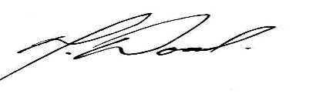

Mark Wood
Managing Director

Date: January 2026

